Unit Two: Ancient Athens

Chapter 3

Name:_______________

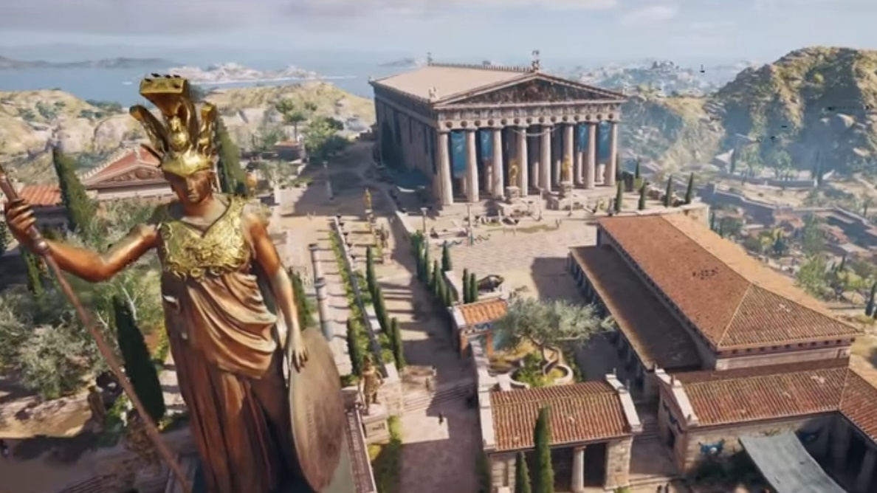

* I can explain the democratic values of the ancient Athenians
* I can describe the process for decision making in Athens
* I can explain the way the government of Athens was organized
* I can explain how citizenship in Athens was affected by what people believed were their proper role, rightsand responsibilities
* I can compare and contrast the qualifications for citizenship
* I can evaluate whether Athenians were treated fairly and equitably by the ideals of their government/ society

**Key Term Definition Visual Representation**

**Ancient Athens🡪Vocabulary**

|  |  |  |
| --- | --- | --- |
| Latitude |  |  |
| Longitude |  |  |
| Cardinal Directions |  |  |
| Social Structure |  |  |
| Class |  |  |
| Rights |  |  |
| Responsibilities |  |  |
| Agora |  |  |
| Boule |  |  |
| Bouleterion |  |  |
| Direct Democracy |  |  |
| Dowry |  |  |
| Artisan |  |  |
| Constitution |  |  |
| Minority |  |  |
| Majority |  |  |
| Philosopher |  |  |
| Unanimous |  |  |
| Ostracize |  |  |
| Bribe |  |  |
| Justice |  |  |

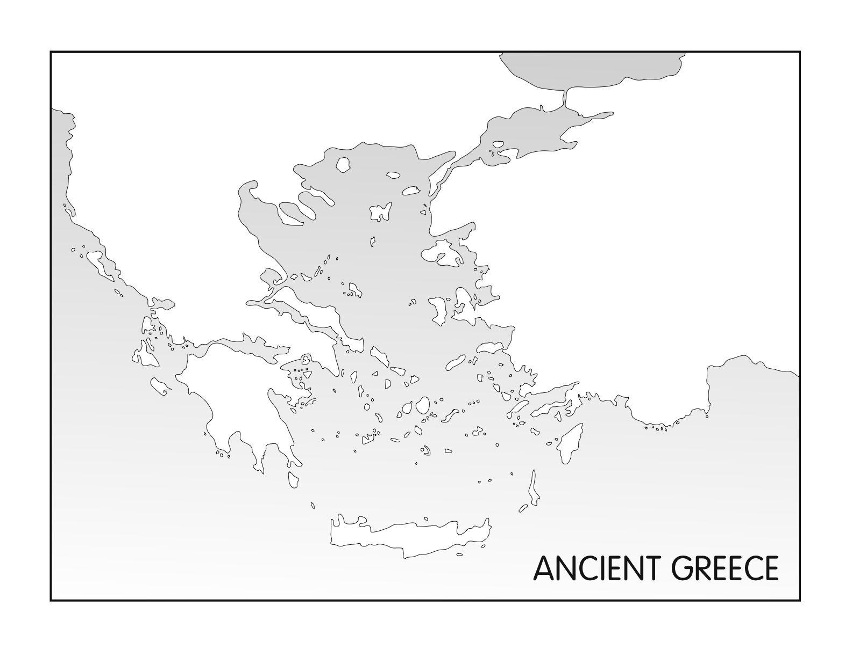Where was Ancient Athens?

Label the following:

Ancient Athens was one of many **City-States** (Mini-countries):

* Each city has its own _____________ (ex. If Athens is a democracy, Sparta may not be)
* Believe in the same _______________
* Share a common __________________
* Had certain allies (other city-states they got along with)
* Has its own ____________
* They thought of themselves as citizens of individual city-states, not Greeks.
* Created by villages coming together to trade and that eventually created large city-states
* 3 major bodies of water
* latitude and longitude
* 5 major cities.
* Cardinal Directions

When was Ancient Athens?

0

500 500 1000 1500 2000

What was the Social Structure of Ancient Athens?

What would be an appropriate title for the diagram above? Make sure it tells the audience EXACTLY what they are looking at. Write it on the line above the triangle.

Men in Athens:

Rights, Roles and Responsibilities

|  |  |
| --- | --- |
| **Male Children** | **Slaves** |
|  |  |
| **Metics** | **Citizens** |
|  |  |

How could males participate in government?

Women in Ancient Athens:  
Rights, Roles and Responsibilities

|  |  |
| --- | --- |
| **Female Children** | **Slaves** |
|  |  |
| **Metics** | **Athenian Women** |
|  |  |

How could females participate in government?

**C:\Program Files\Microsoft Office\MEDIA\CAGCAT10\j0300840.wmfGovernment in Athens**

**The Assembly:**

|  |  |  |
| --- | --- | --- |
| What is it? | Who can be in it? | When and where did they meet? |
|  |  |  |

|  |  |
| --- | --- |
| Who could speak? What was the order? | What type of democracy is it? Explain. |
|  |  |

**The Council of 500 (Boule)**

|  |  |  |
| --- | --- | --- |
| **What is it?** | **How were the members chosen?** | **What did they do?** |
|  |  |  |

How was the government of Athens Structured?

Choose issues for

Citizens

Metics and Athenian Women

SLAVES

LEGEND

Influence Decision Making Power

**Why is there nothing connecting slaves to metics?**

**Ancient Athens Political Structure**

|  |  |
| --- | --- |
| What I Already Know | What I Learned |
|  |  |
|  |  |

**The Legal System/Court System**

Just like Canada has a **legal system** (**people vote** for representatives to make laws, **representatives make laws**, **police enforce** laws, **courts interpret** laws and **prisons carry out** sentences), Ancient Athens also had a legal system. It was considered one of the pillars of Athenian democracy because it allowed people a voice in the decisions of justice.

Let’s read about it and decide what we need to know!!

|  |
| --- |
| C:\Users\Shields\AppData\Local\Microsoft\Windows\Temporary Internet Files\Content.IE5\IR3K1YE3\MC900391156[1].wmf  What pillar of democracy does the legal system relate to?? _________________ |

**The Pillars of Ancient Athens**

The A The C of 500 The C

**Rights and Responsibilities of Athenians**

Use the space below to write down any notes important that you need throughout this unit!!

To what extent were Equity and Fairness part of Athens Government and Society?

Fairness and equity Meter- Circle the number you think represents fairness and equity in Athens. 1 is low, 10 is high.

**1 2 3 4 5 6 7 8 9 10**

Explain why you chose the number you did.

________________________________________________________________________________________________________________________________________________________________________________________________________________________________________________________________________________________________________________________________________________________________________________________________________________________________________________________________________________________________________________________________________________________

**Explain how Athens does or does not show the following principles of democracy.**

|  |  |
| --- | --- |
| Freedom |  |
| Justice |  |
| Representation |  |

**Unit 2: Ancient Athens Study Guide**

You should understand the following terms and concepts for your unit test!

Vocabulary

Latitude

Longitude

Cardinal Directions

Social Structure

Class

Rights

Responsibilities

Agora

Boule

Bouleterion

Direct Democracy

Unanimous

Ostracize

Bribe

Justice

Concepts

* What country is Athens located in?
* What is a city-state?
* What time period are we looking at in ancient Athens? What does BCE and CE stand for? What does “0” represent on a timeline?
* What is the difference between social structure and class?
* What did the social structure of ancient Athens look like? (Triangle)
* What were the rights, roles and responsibilities of *men* in ancient Athens? *Women*? *Children*? *Slaves*?
* How was government structured in ancient Athens?
* What was the Boule (Council of 500)? How were they chosen? Where did they meet?
* What was the Assembly? Who was in it? Where did they meet?
* What kind of democracy was ancient Athens?
* Who had an influence on citizens in government?
* What did the court (justice) system look like in ancient Athens?
* How would someone be ostracized?

C:\Users\MicHeLlE\AppData\Local\Microsoft\Windows\Temporary Internet Files\Content.IE5\FB1VUXB8\MC900090411[1].wmf