**THE IMPORTANT POEM🡪 ROUGH COPY BASIC OUTLINE**

The important thing about \_\_\_\_\_\_\_\_\_\_\_\_\_\_\_\_\_\_\_\_\_\_\_\_\_\_\_\_\_\_\_\_

is \_\_\_\_\_\_\_\_\_\_\_\_\_\_\_\_\_\_\_\_\_\_\_\_\_\_\_\_\_\_\_\_\_\_\_\_\_\_\_\_\_\_\_\_\_\_\_\_\_\_\_\_\_\_\_\_\_\_\_\_\_\_\_\_\_\_\_\_\_.

She/he is \_\_\_\_\_\_\_\_\_\_\_\_\_\_\_\_\_\_\_\_\_\_\_\_\_\_\_\_\_\_\_\_\_\_\_\_.

She/he likes to \_\_\_\_\_\_\_\_\_\_\_\_\_\_\_\_\_\_\_\_\_\_\_\_\_\_\_\_\_\_\_\_.

She/he \_\_\_\_\_\_\_\_\_\_\_\_\_\_\_\_\_\_\_\_\_\_\_\_\_\_\_\_\_\_\_\_\_\_\_\_\_\_\_\_\_\_\_\_\_\_\_\_\_\_\_\_\_\_\_\_\_\_\_\_\_, ­­­­­­­­­­­­­

\_\_\_\_\_\_\_\_\_\_\_\_\_\_\_\_\_\_\_\_\_\_\_\_\_\_\_\_\_\_\_\_\_\_\_\_, \_\_\_\_\_\_\_\_\_\_\_\_\_\_\_\_\_\_\_\_\_\_\_\_\_\_\_\_\_\_\_\_\_\_\_\_\_\_.

But the important thing about \_\_\_\_\_\_\_\_\_\_\_\_\_\_\_\_\_\_\_\_\_\_\_\_\_\_\_\_\_\_\_\_

is \_\_\_\_\_\_\_\_\_\_\_\_\_\_\_\_\_\_\_\_\_\_\_\_\_\_\_\_\_\_\_\_\_\_\_\_\_\_\_\_\_\_\_\_\_\_\_\_\_\_\_\_\_\_\_\_\_\_\_\_\_\_\_\_\_\_\_\_\_\_\_\_\_\_\_.

(SAME AS FIRST LINE!)

\*You need to show this rough copy to Mrs. Hood to have edited for spelling and grammar. Once you receive her initials, you may begin your good copy on a blank piece of white or light coloured paper. Write your good copy in pencil and go over it with a thin black marker. Remember to use a ruler if you need help writing straight. You also need a minimum of 4 pictures! \*

**The Important Poem Rubric**

|  |  |  |  |  |  |
| --- | --- | --- | --- | --- | --- |
|  | sunny_c.gif Sunny day image by TeachESL (4) | http://rtv6blogs.com/rtv6_stormteam6/files/2009/05/sunclouds.jpg **(3)** | http://www.edupics.com/01cloudy-t9946.jpg **(2)** | **http://www.faa.gov/education/educator_resources/educators_corner/grades_k_3/charting_weather/images/rainy.gif(1)** | Point(s) Earned |
| **Poem Lines** | I have included all lines in my poem. My lines makes the reader smile ☺ | I have most of the lines for the poem or they don’t all make sense | I have ½ of the lines for my poem or they do not make sense | I need to go back and re write my lines until my poem is awesome | x 2 : \_\_\_\_\_\_\_ |
| **Illustrations** | I have included 4 *fabulous* illustrations to go with the poem | I have included at least 3 illustrations to go with each awesome thing. I think I could have put a bit more effort into my illustrations | I have included 2-3 illustrations but I did not do my best work and they are sloppy | I need to redo my illustrations ☹ | \_\_\_\_\_\_\_ |
| **EFFORT** | I would LOVE to show this to the Prime Minister of Canada.  The product shows that MUCH time and effort was used. | I would like to share this with the mayor of Lethbridge.  The product is quality work. | I am okay with sharing this with Mrs. Hood. The product is average work. | I really need to hide this from my parents.  I am not very proud of this | \_\_\_\_\_\_\_ |
| **TOTAL 🡪\_\_\_\_\_\_\_\_\_/16** | | | | | |

**The Important Poem**

**The important thing about Mrs. Hood is that she’s a mom and a teacher.**

**She is married.**

**She likes to drink coffee and watch movies.**

**She loves animals, learning about history, and John Stamos.**

**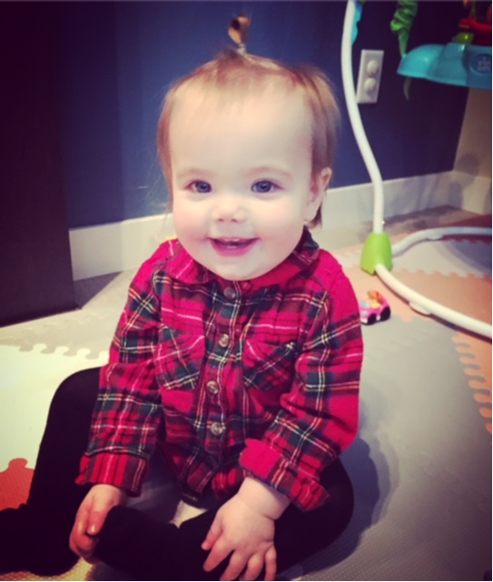**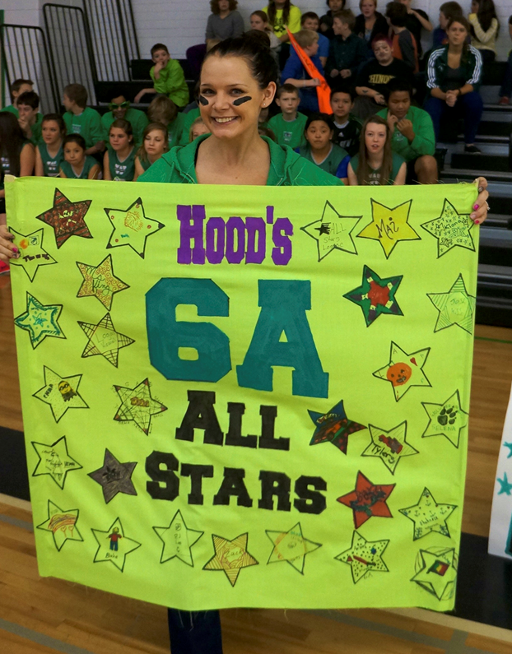**But the important thing about Mrs. Hood is that she’s a mom and teacher.**

