**UNIT 5: LEVELS OF GOVERNMENT**

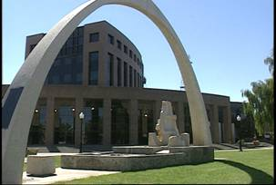PART A - LOCAL (CHAPTER 8)

NAME:________________ CLASS:________________

**I can describe the structure and functions of local government in Alberta.**

• I know how representatives are chosen to form a local government (i.e., electoral process)

• I know the responsibilities of local governments (i.e., bylaws, taxes, services)

• I can explain how local governments are structured differently in rural and urban settings

• I can explain the role played by school boards (i.e., public, separate, Francophone) within local communities

|  |
| --- |
|  |
| Local Governments: |
| Mayor: |
| Councillors: |
| Wards: |
| Reeve: |
| Municipalities: |
| First Nations Authorities (FNA’s): |
| Nomination: |
| Debates: |
| Forums: |
| Oath: |
| Polling Stations: |
| Scrutineer: |
| Returning Officer: |
| Agenda: |
| Transparency: |
| Minutes: |
| Council Chambers: |
| Bylaw: |
| Taxes: |
| Department: |
| School Board: |
| Trustee: |
| Budget: |
| Publicly Funded: |
| Rally: |

**C:\Program Files\Microsoft Office\MEDIA\CAGCAT10\j0297185.wmf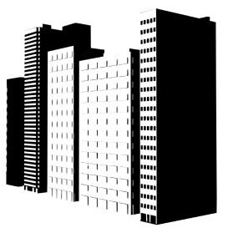Types of Local Government**

**Rural, Urban and First Nations Governments**

|  |  |  |  |  |
| --- | --- | --- | --- | --- |
| **Type of Government** | | **Population size** | **Characteristics and/ or Example Communities** | **Representatives** |
| **Number found in Alberta** |
| **Urban Municipal Government** | **Cities** |  |  | **Top Elected Official:**  **Other Representatives:**  **How are they selected?:** |
|  |
| **Town** |  |  | **Top Elected Official:**  **Other Representatives:**  **How are they selected?:** |
|  |
| **Villages** |  |  | **Top Elected Official:**  **Other Representatives:**  **How are they selected?:** |
|  |
| **Type of Government** | | **Number in Alberta** | **Characteristics and/ or Example Communities** | **Representatives** |
| **Rural Municipal Government** | **Municipal Districts (Counties)** |  |  | **Top Elected Official:**  **Other Representatives:**  **How are they selected?:** |
|  |
| **Specialized Municipalities** |  |  | **Top Elected Official:**  **Other Representatives:**  **How are they selected?:** |
|  |
| **Métis Settlement Councils** | |  |  | **Top Elected Official:**  **Other Representatives:**  **How are they selected?:** |
|  |
| **First Nations Authorities** | |  |  | **Top Elected Official:**  **Other Representatives:**  **How are they selected?:** |

**C:\Users\hoodmich\AppData\Local\Microsoft\Windows\Temporary Internet Files\Content.IE5\850Y66EK\MC900411854[1].wmf**

**How are Representatives Elected to Form a Local Government?**

**What Responsibilities Do Local Governments Have?**

|  |
| --- |
| TAXES: |
| SERVICES:   |  |  |  | | --- | --- | --- | | **C:\Users\hoodmich\AppData\Local\Microsoft\Windows\Temporary Internet Files\Content.IE5\LHQXRXVK\MC900092749[1].wmf** | **C:\Users\hoodmich\AppData\Local\Microsoft\Windows\Temporary Internet Files\Content.IE5\E0FG7HE5\MC900438706[1].jpg** | **C:\Users\hoodmich\AppData\Local\Microsoft\Windows\Temporary Internet Files\Content.IE5\850Y66EK\MC900029984[1].wmf** | | **C:\Users\hoodmich\AppData\Local\Microsoft\Windows\Temporary Internet Files\Content.IE5\WRWPF7GX\MC900433940[1].png** | C:\Users\hoodmich\AppData\Local\Microsoft\Windows\Temporary Internet Files\Content.IE5\E0FG7HE5\MC900028383[1].wmf | C:\Users\hoodmich\AppData\Local\Microsoft\Windows\Temporary Internet Files\Content.IE5\LHQXRXVK\MC900231362[1].wmf | | C:\Users\hoodmich\AppData\Local\Microsoft\Windows\Temporary Internet Files\Content.IE5\8TEV6XLB\MC900053326[1].wmf | C:\Users\hoodmich\AppData\Local\Microsoft\Windows\Temporary Internet Files\Content.IE5\850Y66EK\MC900311932[1].wmf | C:\Users\hoodmich\AppData\Local\Microsoft\Windows\Temporary Internet Files\Content.IE5\E0FG7HE5\MC900351359[1].wmf | |

**How Do You Pass a Bylaw?**

Give an example of 3 bylaws:

|  |  |  |
| --- | --- | --- |
|  |  |  |

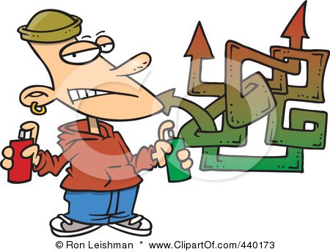**C:\Users\hoodmich\AppData\Local\Microsoft\Windows\Temporary Internet Files\Content.IE5\YLRTGD8U\MC900198606[1].wmf**

**C:\Users\hoodmich\AppData\Local\Microsoft\Windows\Temporary Internet Files\Content.IE5\WRWPF7GX\MC900435544[1].wmfSCHOOL BOARDS**

**What kinds are found in Alberta?**

|  |  |  |
| --- | --- | --- |
| P____________ | S______________ | F______________ |

**What Do School Boards Do?**

C:\Users\hoodmich\AppData\Local\Microsoft\Windows\Temporary Internet Files\Content.IE5\8TEV6XLB\MC900134537[1].wmf