GRADE SIX SOCIAL STUDIES FINAL EXAM NAME:___________________

- Which of the following rights or freedoms from the Canadian Charter of Rights and Freedoms guarantees parents the right to have their child educated in a Francophone school?

  - Freedom of association
  - Official languages rights
  - Minority language education rights
  - Freedom of conscience and religion

Use the information from the following source to answer question 2.

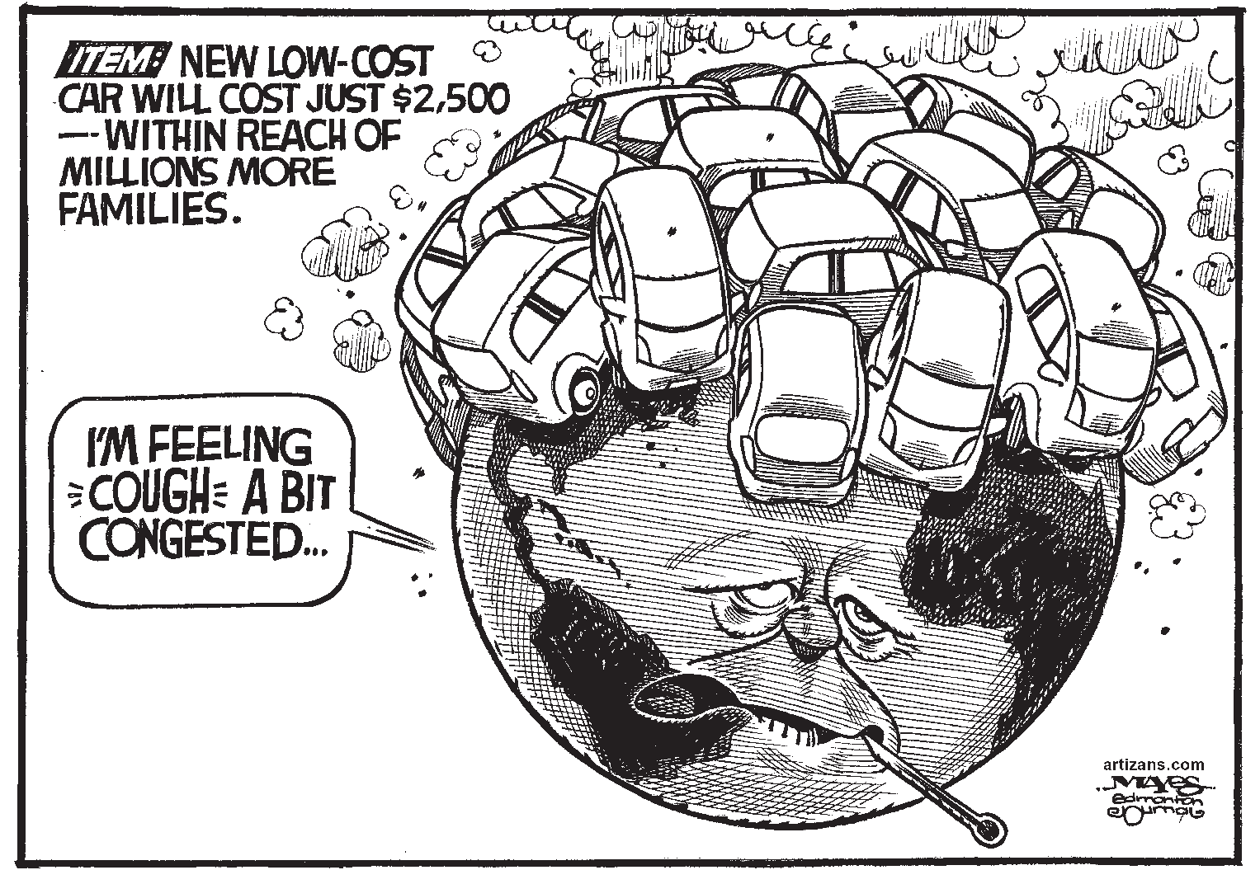

- According to the Canadian Charter of Rights and Freedoms, the publication of the cartoon shown above in a newspaper is an example of

  - the freedom of association
  - the freedom of expression
  - a democratic right
  - a legal right

- The best example of mobility rights as described in the Canadian Charter of Rights and Freedoms is

  - transferring to a new school
  - moving to another province
  - having wheelchair access
  - getting a driver’s license

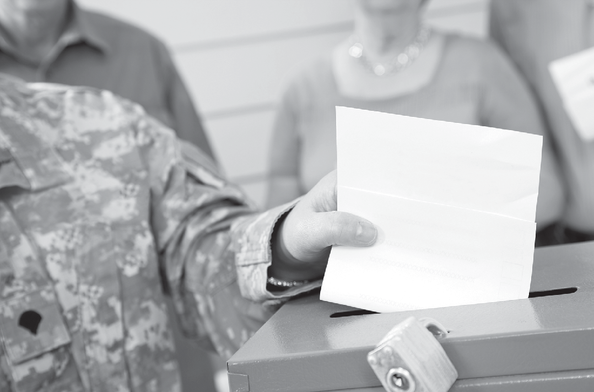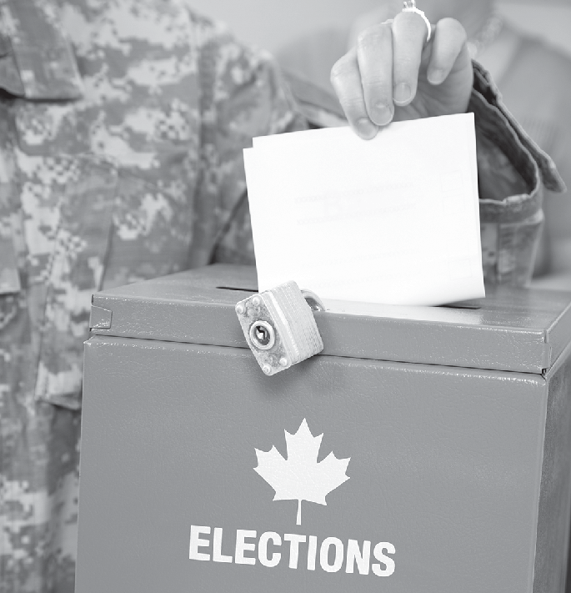Use the following source to answer questions 4 to 6.

Troops in Afghanistan (and all electors in the Canadian Forces) vote by special ballot where they are stationed.

- What right in the Canadian Charter of Rights and Freedoms is being demonstrated in the photographs and caption?

  - A democratic right
  - An equality right
  - A mobility right
  - A legal right

- Which of the following titles best describes the activities in the photographs?

  - Collective rights
  - Petition gathering
  - Active citizenship
  - Consensus building

- What is the most likely reason that Canadian soldiers serving in Afghanistan would be voting in an Alberta election?

  - Modelling their democratic rights for locals
  - Following the directions of their commander
  - Voting to make changes in the Afghanistan government
  - Exercising individual rights and responsibilities as citizens

- One characteristic of democracy is that

  - by law, citizens are required to vote
  - the government is accountable to the people
  - only property owners have a say in decision making
  - social standing determines a person’s level of influence

- Which of the following graphics represents a price list that demonstrates equality?

- A similarity between a direct democracy and a representative democracy is that

  - only citizens who belong to a political party are entitled to vote
  - issues must be agreed upon by a majority of the decision makers
  - individual rights are more important than collective responsibility
  - class structure affects the influence a citizen has when making decisions

- Enforcement of a bylaw by police is an example of which of the following principles of democracy?

  - Representation
  - Freedom
  - Equality
  - Justice

Use the following information to answer questions 11 and 12.
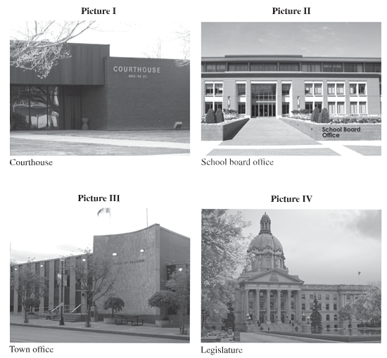
Grade 6 students researched the responsibilities of officials who work in the buildings shown in the photographs below.

- Locations which represent local government operations are shown in pictures

  - I and II
  - I and IV
  - II and III
  - III and IV

- Picture IV best represents which of the following features of democracy?

  - Equity
  - Justice
  - Freedom
  - Representation
Use the following information to answer question 13.

Steps in a Provincial Election Process
1 | Interested citizens attend public debates.
2 | Voters go to polling stations and vote for a candidate.
3 | The premier asks the lieutenant governor to dissolve government.
4 | The candidate with the most votes wins and becomes the elected member for the riding.

- The steps in a provincial election process described above are correctly ordered as
A. | 1, 4, 3, 2
B. | 2, 3, 1, 4
C. | 3, 1, 2, 4
D. | 4, 1, 3, 2

- In order to become premier of the province of Alberta, a person must

  - have a university degree
  - speak both official languages
  - have already served as mayor of a large city
  - be the leader of the political party that wins the election

- Which of the statements below identifies someone who meets the requirements to run in a municipal election in Edmonton, Alberta?

  - I was born in Calgary and moved to Edmonton a year ago. I am 20 years old.
  - I was born in Japan and moved to Edmonton one month ago. I am 21 years old.
  - I was born in Edmonton and have lived here my whole life. I am 17 years old.
  - I was born in India 25 years ago and became a Canadian citizen four years ago.
I have lived in Edmonton for two months.

- Alberta citizens who vote have a voice in the Legislative Assembly of Alberta because they

  - elect members to the Legislative Assembly
  - are able to introduce bills in the Legislative Assembly
  - choose the sergeant-at-arms of the Legislative Assembly
  - are able to participate in debates in the Legislative Assembly

Use the following information to answer questions 17 and 18.
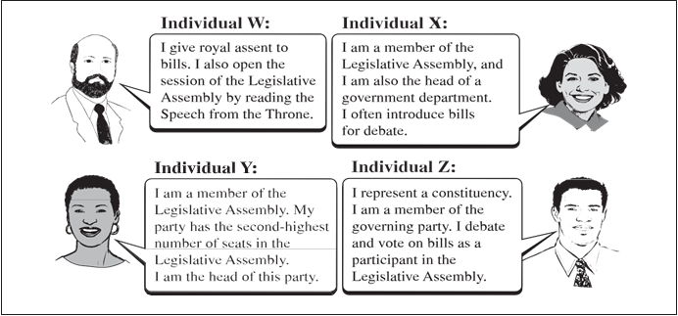

- Which individual is responsible for the swearing in of the premier and other members of the Legislative Assembly?

  - Individual W
  - Individual X
  - Individual Y
  - Individual Z

- All four individuals are members of a decision-making body known as a

  - minority-rights association
  - provincial government
  - local government
  - school board

- The political party with the second-largest number of seats in the Legislative Assembly of Alberta

  - appoints the Speaker of the House
  - becomes the Official Opposition
  - establishes a lobby group
  - forms the government

Use the following information to answer question 20.

- The delegation in the news article demonstrates active citizenship by

  - protesting at city hall
  - writing a letter to the mayor
  - submitting a presentation to the school board
  - lobbying a member of the Legislative Assembly

- Which of the following actions is both a right and a responsibility of a citizen in Alberta?

  - Voting in elections
  - Obeying the laws of Alberta
  - Helping others in the community
  - Receiving an education in English and French

Use the following information to answer questions 22 to 25.
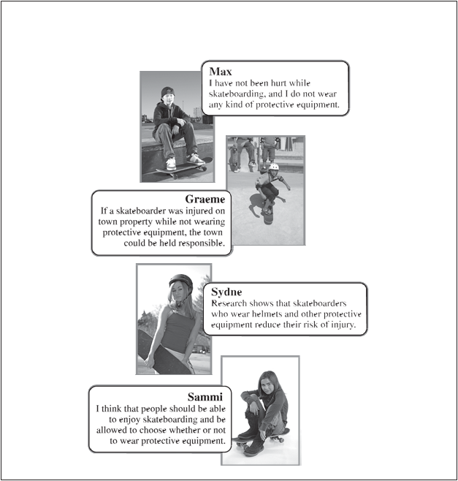
A local council is considering a proposal that would require skateboarders to wear protective equipment while skateboarding. Below are four individuals’ comments on the issue.

- If the local council approves the proposal, it becomes a

  - bylaw
  - debate
  - service
  - petition
23. The most effective way for individuals to influence the outcome of the protective equipment proposal is to

A. circulate a petition
B. join a political party
C. make a presentation to the school board
D. write a letter to their provincial government representative

24. Which individual is most clearly stating an opinion?

A. Max
B. Graeme
C. Sydne
D. Sammi

25. Which two individuals would most likely support a proposal that would require the use of protective equipment while skateboarding?

A. Max and Graeme
B. Max and Sammi
C. Graeme and Sydne
D. Sydne and Sammi

26. Students organized a family dance to promote a local charity. By doing this, they are exhibiting a responsibility of active citizenship by

- becoming more physically active
- taking action to help people in need
- developing positive social relationships
- influencing government decision making

Use the following blog to answer questions 27 to 29.
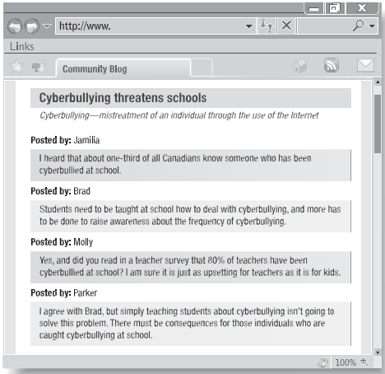

- Using the information from the blog, which two speakers have offered suggestions on how to solve the issue of cyberbullying?

  - Jamilia and Brad
  - Jamilia and Molly
  - Parker and Brad
  - Parker and Molly

- Based on the information from the blog, which individual used a fact to support an opinion?

  - Jamilia
  - Brad
  - Molly
  - Parker

- The best reason to use sources other than a blog in a research project is that

  - blogs do not provide enough information
  - spelling and grammar in a blog lack accuracy
  - blogs do not give the full identity of the blogger
  - information provided in blogs may be biased

Use the following information to answer questions 30 to 32.

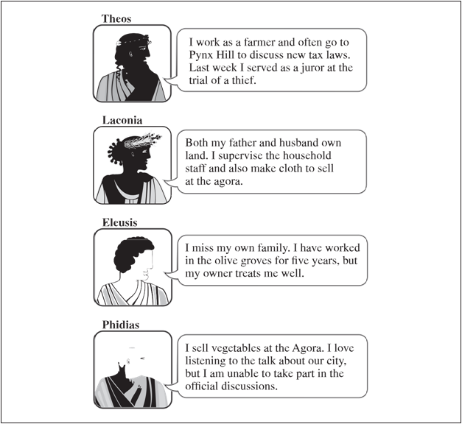
- Which two speakers were most likely born outside of Athens?

  - Theos and Laconia
  - Theos and Eleusis
  - Phidias and Laconia
  - Phidias and Eleusis

- The speaker who is most likely a metic is

- Theos
- Laconia
- Eleusis
- Phidias

- The speaker who had no rights in ancient Athenian democracy is

- Theos
- Laconia
- Eleusis
- Phidias

- Which of the following statements best illustrates direct democracy in ancient Athenian government?

- All citizens were required to attend and vote at the Assembly.
- Citizens could serve on Council only twice in their lifetime.
- Any citizen could be chosen to be on a jury for a trial.
- Council members represented the Athenian citizens.

Use the information from the following source to answer questions 34 to 36.
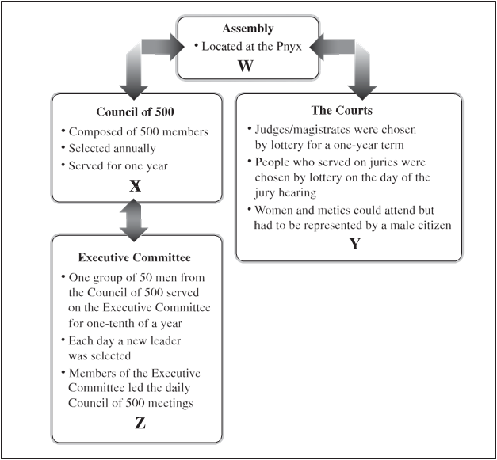

- Which of the following statements would be accurately placed in location W?

- Involved debating and voting by male citizens
- Carried out decisions made at the Council of 500
- Provided a location for the selling and trading of goods
- Allowed women and slaves to voice their opinions on issues

- According to the information in the flowchart, how did the Council of 500, the Courts, and the Executive Committee attempt to ensure fairness and equity in their structure?

- They met at the Pnyx.
- Metics were allowed to participate.
- Members of these groups were selected randomly.
- They allowed only wealthy individuals to participate.

- Which of the following titles would be best suited for the information flowchart?

- “Class Structure in Ancient Athens”
- “The Role of Women in Ancient Athens”
- “Structure of Government in Ancient Athens”
- “The Role of the Courts in Decision Making in Ancient Athens”

Use the following table to answer question 37.
Position | How They Were Chosen
Assembly | Nominated by fellow citizens
Military leader | A show of hands by individuals
Council of 500 member | X
Officer of the court | Highest number of white stones in a jug

- Which of the following statements would be correctly placed in location X?

- Name most often scratched on pottery
- Participants used a lottery system
- Volunteers asked for the position
- Every tenth person was selected

- Ancient Athens had its greatest influence in Canada today in the area of

- warfare
- government
- construction
- shipbuilding

- The part of Alberta’s provincial government that the Council of 500 is most similar to is the

- Cabinet
- premier
- House Speaker
- Legislative Assembly
- Women in the Iroquois Confederacy influenced the decision-making process of the Iroquois Confederacy because women selected

- the location where the Grand Council would meet
- issues that were to be discussed by the Grand Council
- chiefs who represented each of the nations at the Grand Council
- the number of representatives each nation could send to the Grand Council

- At the Grand Council, the Mohawk Nation was responsible for

- arranging the seating order of each nation
- recording the votes of the different nations
- announcing any decisions that had been made
- organizing the sharing of food after the meeting

- Evidence of decisions made years ago by the Grand Council of the Iroquois Confederacy can be found on

- tree bark
- peace pipes
- walls of caves
- wampum belts

- A chief from any First Nations group who did not act with the welfare of the clan in mind could be

- reported to the French governor for punishment
- given a warning by the chiefs from the Grand Council
- replaced by another male member under the authority of the clan mother
- required to explain his actions to chiefs from the Mohawk and Oneida groups

- Democratic principles were built into decision making in the Grand Councils of the Iroquois Confederacy by ensuring that

- females had their views delivered
- all chiefs were equal and had the same level of authority
- only the men of the First Nations groups would participate in decision making
- the Onondaga clan was responsible for guarding the group against outside threats
Use the following information to answer question 45

- Why would the Tuscarora nation most likely want to join the Iroquois Confederacy?

- Members of the Tuscarora nation were known for strength and bravery.
- The land claimed by the Tuscarora was in the middle of land occupied by other nations.
- The Tuscarora’s knowledge of the land would allow them to teach the other nations how to become successful farmers.
- Members of the Tuscarora nation wanted to help increase the population of the Iroquois Confederacy that had been reduced by illness and warfar
- A result of the signing of the treaty of La Grande Paix de Montréal was that

- many other First Nations adopted the Iroquois Confederacy’s Great Law of Peace
- the French returned Montréal to the First Nations groups who signed the treaty
- the First Nations groups agreed to keep peace among themselves
- treatment of diseases was improved for First Nations

- The society of the Iroquois Confederacy passed on the meaning of wampum belts from generation to generation by

- recording the meaning in a book
- teaching others to orally repeat the meaning
- storing the wampum belts in public buildings
- using photographs to record the image of wampum belts

Use the following information to answer questions 48 and 49.

Before 1500 The Iroquois Confederacy is established. The Great Law of Peace forms the constitution of the Iroquois Confederacy.
1609 Samuel de Champlain (a French explorer) and his First Nations allies battle the Mohawk.
1642 Montréal is founded by the French.
1648–1649 The Iroquois and the Huron are at war.
1650 War and smallpox outbreak kill many Iroquois.

Late 1670s–1700 The Iroquois are in conflict with Algonquin-speaking tribes of the Great Lakes region.
1701 Treaty of La Grande Paix de Montréal is signed.
1722 The Tuscarora join the Iroquois Confederacy as the sixth nation.

- The information in the timeline supports which of the following statements?

- The Iroquois Confederacy was involved in conflict over a long period of time.
- The Iroquois Confederacy cooperated with outsiders often throughout their history.
- The main challenge faced by the Iroquois Confederacy involved working with explorers.
- The main challenge faced by the Iroquois Confederacy to sign the Great Law of Peace was the smallpox outbreak.

- The information in the timeline would be used to answer which of the following questions?

- What events led up to the Confederacy’s desire to attend the peace talks in Montréal in 1701?
- What effect did geography have on the Iroquois Confederacy’s decision to attend the peace talks in Montréal in 1701?
- Was the smallpox epidemic a problem for members of the Iroquois Confederacy?
- Why did the Tuscarora nation join the Iroquois Confederacy in 1722?

- Which of the following statements is the best example of equality in the Iroquois Confederacy?

- The chief was treated with respect, but he did not control the members of his clan.
- The duties of the clan mother were passed down from mother to daughter.
- The spiritual leader had great influence on the members of his clan.
- The Tuscarora were represented by the chiefs of the Oneida nation.

