UNIT 1: Canadian Democracy

PART A Chapters 1 & 2

C:\Documents and Settings\sherrie.nickel\Local Settings\Temporary Internet Files\Content.IE5\8745UBK3\MCj04379980000[1].wmf

Name ______________________________________________

* I can explain what a democracy is
* I can explain and apply effective group work skills
* I can explain three ways to make decisions and the negative and positive attributes of each
* I can differentiate between fairness & equity, and equality
* I can apply the four principles that support democracy

MCj04115840000[1]

**Democracy**

Democracy is _______________________________________________ ______________________________________________________________________________________________________________________________________________________________________________

**Working in a Group**

In a group I need to ____________ others, ____________ to work and ___________myself.

Rationale:____________________________________________________________________________________________________________

Opinions:____________________________________________________________________________________________________________

Perspectives:_________________________________________________________________________________________________________

**C:\Documents and Settings\shieldjo\Local Settings\Temporary Internet Files\Content.IE5\Q5QNQRIZ\MC900280925[1].wmfThree Ways to Make Decisions**

**A good title for this chart would be:**

**_______________________________________________________**

|  |  |  |
| --- | --- | --- |
| Type of Decision Making | Advantages | Disadvantages |
| C:\Documents and Settings\shieldjo\Local Settings\Temporary Internet Files\Content.IE5\12GQBHKZ\MC900297513[1].wmfVoting |  |  |
| C:\Documents and Settings\shieldjo\Local Settings\Temporary Internet Files\Content.IE5\12GQBHKZ\MC900355407[1].wmfConsensus |  |  |
| RepresentativesC:\Documents and Settings\shieldjo\Local Settings\Temporary Internet Files\Content.IE5\KJ4XK3WV\MC900440036[1].wmf |  |  |

Which would be the best for a group of 5 making a decision and why?

Which would be the best for a classroom making a decision and why?

Which would be the best for a school making a decision and why?

**Fairness and Equity, and Equality**

Copy the examples from page 26 and provide information for each example explaining how it shows fairness and equity, or equality. Why is it important for each example?

|  |  |
| --- | --- |
| **Fairness and Equity** | **Equality** |
|  |  |
|  |  |
|  |  |
|  |  |

Add an additional example in the last section of the table.

Democracy and the Four Principles

The term democracy comes from—*demokratia*, from *demos* meaning common people + *kratos* meaning rule, strength, power.

To function effectively, democracies must ensure an active role for the people through four key principles:

If a government is run on these principles it is a **democracy**, so we would call it a _____________ government!

**C:\Documents and Settings\shieldjo\Local Settings\Temporary Internet Files\Content.IE5\I50Z0D6N\MC900391740[1].wmfTwo types of democracy:**

* **Direct democracy**🡪 A way of making decisions in which everyone in a group votes (no representatives)
* **C:\Documents and Settings\shieldjo\Local Settings\Temporary Internet Files\Content.IE5\2LRQN974\MC900056644[1].wmfRepresentative democracy**🡪 a political system where citizens elect representatives to govern and make decisions on their behalf.

**Canada’s government is a ____________ democracy!!**

**C:\Documents and Settings\shieldjo\Local Settings\Temporary Internet Files\Content.IE5\12GQBHKZ\MC900332022[1].wmfGovernment & Democracy**

**Government🡪** ________________________________________ ____________________________________________________

**C:\Documents and Settings\shieldjo\Local Settings\Temporary Internet Files\Content.IE5\I50Z0D6N\MC900013449[1].wmfCanada has three main Levels of Governments:**

We also have First Nations governments in Canada at all three levels.

* **Federal=** Whole country

**C:\Documents and Settings\shieldjo\Local Settings\Temporary Internet Files\Content.IE5\KJ4XK3WV\MC900027362[1].wmf**

* **Provincial=** Each province

**C:\Documents and Settings\shieldjo\Local Settings\Temporary Internet Files\Content.IE5\F5HD2O22\MC900053559[1].wmf**

* **Local/Municipal=** Cities, town, or district

**All Levels of Governments are Responsible for Three Main Things:**

**Each level of government is responsible for making laws, providing services and collecting taxes for the people they represent.**

**Example: The Federal Gov’t makes laws for the _____________, the Provincial gov’t makes laws for the ___________, the Municipal/local Gov’t make laws for the _______________________.**

**Laws (Regulations)**

How do Government LAWS/regulations Affect You?



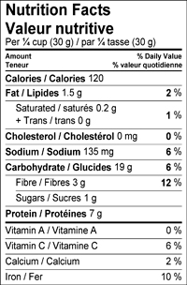

C:\Documents and Settings\shieldjo\Local Settings\Temporary Internet Files\Content.IE5\12GQBHKZ\MC900322688[1].wmf

What is a regulation?

Why are regulations important?

Governments provided services for the people based on their needs. Below are 11 main services provided by Canada’s government. Some are federal services, some municipal and some provincial. Below each, explain why they are important services.

**Government Services**🡪 Pg. 40-43

1. Hospitals
   * 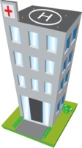
2. Snow Plows
3. C:\Documents and Settings\shieldjo\Local Settings\Temporary Internet Files\Content.IE5\8XINW56B\MCj04241540000[1].wmfFirefighters
4. Recycling
5. Road construction
6. Historic sites and museums
7. C:\Program Files\Microsoft Office\MEDIA\CAGCAT10\j0183328.wmfSchools
8. Public parks
9. Public Library
10. C:\Documents and Settings\shieldjo\Local Settings\Temporary Internet Files\Content.IE5\BF5X91XM\MCj04241740000[1].wmfPolice officers
11. Public Transportation

**NOT FOR FREE!!**

**Services cost money, just think about how much it cost to plow the city of Lethbridge after a big snow storm!! To pay for services the government needs some serious $$$! How do you think they get that $$$?**

**YOU GOT IT🡪TAXES!!!!**

**TAXES**

**Taxes:_______________________________________________________________________________________________________________________________________________________________________________________________**

Just so you know, there are A LOT of people involved in the government. List 5 different government groups from pages 46-47.



There are also A LOT of ways to participate in government, which we will discuss later as well! List the 5 ways on pages 48-49. The more you remember the better!



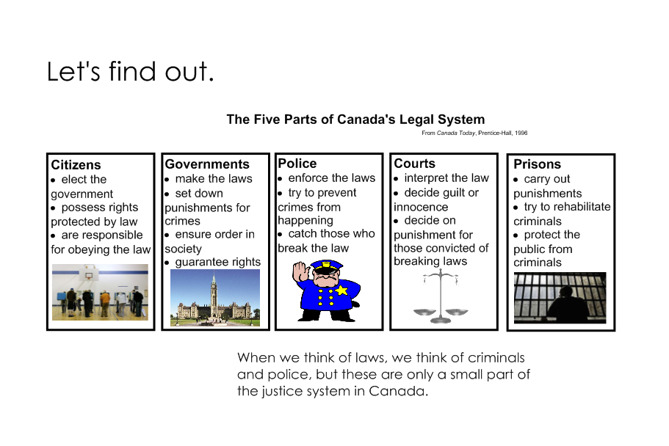**CANADA’S JUSTICE SYSTEM**