Life of the Charter
Task: you must create a “Life of the Charter” board game.
Using poster board, you will construct a board game, similar to the format of the game “Life” using the Charter of Rights and Freedoms as your guide.
The game will be split into 3 main sections:
The first section (smallest) will be the historical significance surrounding the Charter.
The second section will be the creation and different parts of the Charter. (fundamental freedoms, individual rights, collective rights)
The third section (largest) will be scenarios applicable to the Charter.

Here is an outline of the information needed in your board game:
Section 1 – History (atleast 3 spaces):
- 1701- La Grande Paix de Montreal- established peace and respect among the French and First Nations people in what is now Eastern Canada
You are a French fur trader and you do not follow the hunting grounds, as you hunt west of Lake Ontario. Move back 3 spaces.
For example:

Section 2 – Information from the Charter of Rights and Freedoms (atleast 7 spaces):
- You must include 1 space for each of the following:
Fundamental Freedoms, Democratic Rights, Mobility Rights, Legal Rights, Equality Rights, Official Languages of Canada, Minority Language Educational Rights,
For example:
You may live, work or travel anywhere in Canada. What right is explained here?

Section 3 – Scenario based application of the Charter of Rights and Freedoms (atleast 10 spaces):
- You must include scenario based/application questions for each section of the Charter of Rights and Freedoms.
For example:
Skylar was sentenced to 20 years in prison without a trial. What Right or Freedom has been violated?

Make the board game your own!
- Use different game pieces!
- Make interesting: move back/move forward spaces, lose your turn, etc!
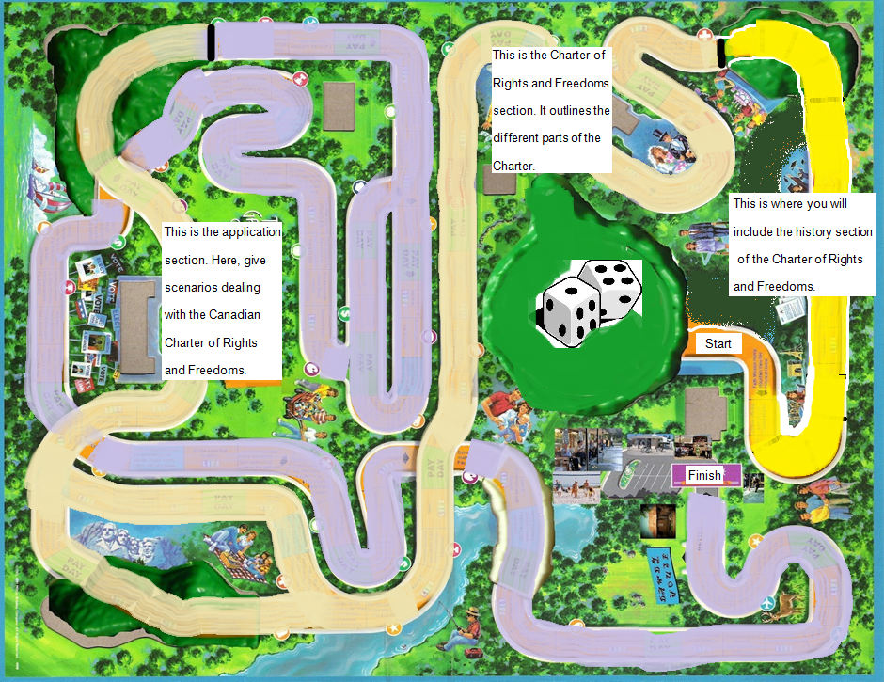
- Make it colourful and decorative!
The Life of the Charter

