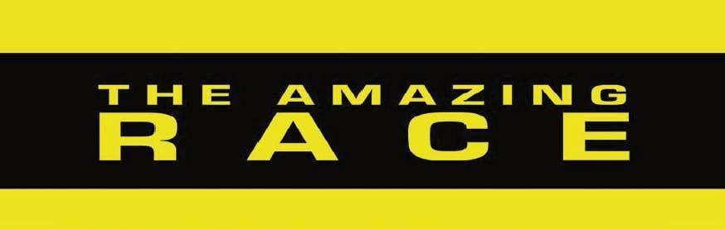
Ancient Athens
Our next unit in Social Studies is on the democratic principles of Ancient Athens. Students will be broken up into teams of 4 or 5. The teams will need to cooperate to complete the challenges well and in a timely manner. There are 3 different types of activities in this unit:

Challenge- teams work together to complete the challenge first *stickers awarded
Roadblock- the roadblock is an activity that must be completed before a team may begin their next challenge
Pit Stop- a ‘time out’ in the game where the class will learn about new information, discusses what they have learned or have an assessment.
-----
The winning team of each challenge will earn stickers:
1st place team- 3 stickers
2nd place team- 2 sticker
3rd place team- 1 sticker

The team with the most stickers will earn a pizza party with the teachers.

Activity | Learning Objective
Ancient Athens Pre Teaching Pit Stop
Challenge 1- Where in the World is Ancient Athens?
Pit Stop- Timeline of my Life
Challenge 2- The Timeline
Roadblock 1- The Greek Alphabet | I can explain how the government was structured in Ancient Athens. (direct vs representative democracy)
Pit Stop- Who’s Who in Ancient Athens? The Social Structure | I can explain how identity, status and class structure impacted citizenship in Ancient Athens.
Roadblock 2- The Brochure
Challenge 3- Employee of the Month
Roadblock 3- Social Structure Pyramid | I can explain how the social structure of Ancient Athens impacted the government.
Challenge 4- The Tower of Power
Pit Stop- Social Structure Quiz
Roadblock 4- To Go Or Not To Go To War | I can explain how fairness and equity was part of the social and political structure in Ancient Athens.
Challenge 5- Sock War
Pit Stop- The Government Structure | I can explain how the government was structured in Ancient Athens.
Challenge 6- Greek Mythology
Unit Exam
Agora Day

