The “Write” Stuff: Paragraphs Name:_____________
Topic Sentence:

The topic of the paragraph is stated in one sentence at the beginning.

Supporting details:

The rest of the paragraph consists of sentences that develop or explain the main idea.

Clincher/Ending:

Restate the topic sentence in different words. It summarizes the paragraph.

Ways to Develop a Paragraph:
You can develop by giving examples, giving details or telling an incident.
Unity and Order in a Paragraph:
Every sentence in a paragraph should support the main idea expressed in a topic sentence. Stick to the point in a logical order: 1. Chronological OR 2. Relationship OR 3. Importance
Four Types of Paragraphs:
Narrative: Tells a story | Persuasive:  Tries to convince the audience | Descriptive:  Describes something in detail | Expository:  Gives information or explains something

The “Write” Stuff
Transition Words: Words that link idea’s (sentences or paragraphs) together. These help your writing flow. If you are not using these types of words, your writing will not be the best it can be. Here is a little look at transitions.
Chronologically | Ordered in relation to each other | Ordered by importance
- First  - Meanwhile  - Later  - Afterwards  - Finally | - Next to  - In front of  - Beside  - Between  - Behind | - However  - Furthermore  - As a result  - In fact  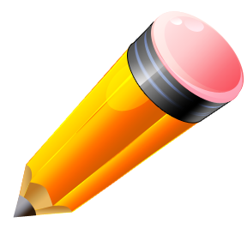  - yet

Add 9 GREAT transition words to the lists above!
For practice, let’s write a paragraph!

