UNIT four: active citizenship

Participating in a representative democracy

Chapters 6 & 7

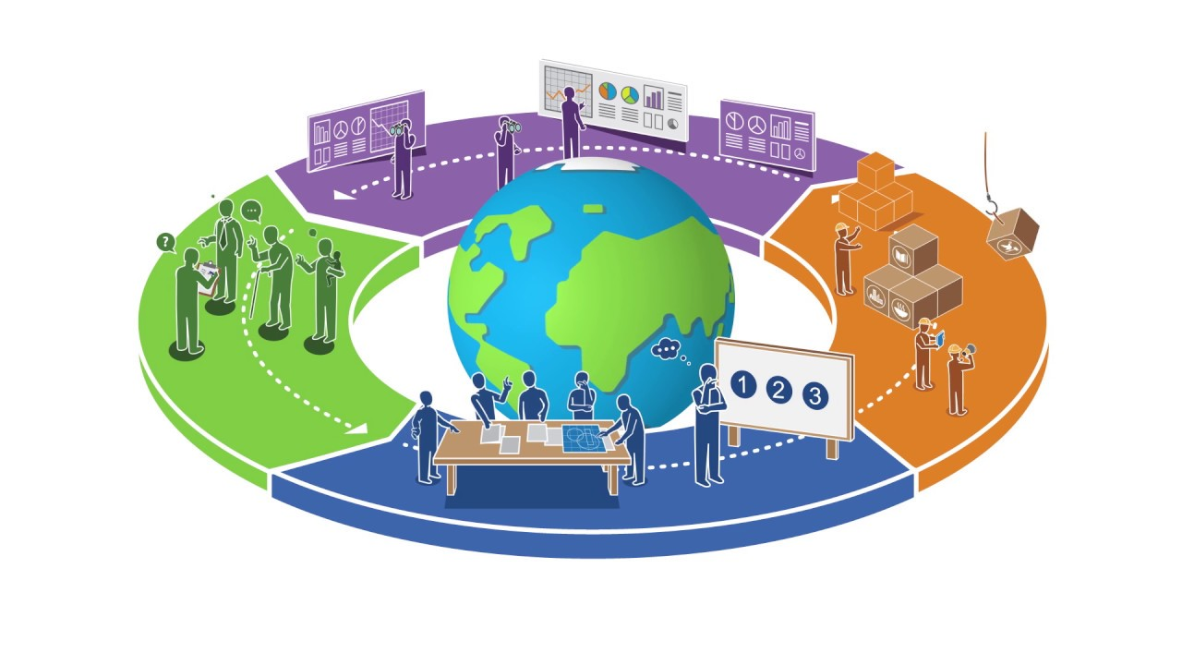

Name ______________________________________________

* I can describe the rights and responsibilities of citizens living in a representative democracy
* I can explain the similarities and differences between direct and representative democracies
* I can value the contributions of elected representatives in the democratic process
* I can value the participation of citizens
* I can describe how elected officials demonstrate accountability to the electorate
* I can explain how ACFA and MNAA provide their members with a voice to exercise their rights
* I can describe how individuals, groups and associations within a community participate in the decision-making process regarding current events or issues

**Government & Democracy**

**C:\Documents and Settings\shieldjo\Local Settings\Temporary Internet Files\Content.IE5\12GQBHKZ\MC900332022[1].wmfGovernment🡪** a person or persons ruling a country, province, city, district, etc.

**C:\Documents and Settings\shieldjo\Local Settings\Temporary Internet Files\Content.IE5\I50Z0D6N\MC900013449[1].wmfCanada has three main types of Governments:**

**We also have First Nations governments in Canada at all three levels.**

* **Federal=** Whole country

**C:\Documents and Settings\shieldjo\Local Settings\Temporary Internet Files\Content.IE5\KJ4XK3WV\MC900027362[1].wmf**

* **Provincial=** Each province

**C:\Documents and Settings\shieldjo\Local Settings\Temporary Internet Files\Content.IE5\F5HD2O22\MC900053559[1].wmf**

* **Local/Municipal=** Cities, town, or districts

**Two types of democracy:**

* **Direct democracy**🡪 A way of making decisions in which everyone in a group votes on all issues (no representatives)
* [](http://www.google.ca/url?sa=i&rct=j&q=vs&source=images&cd=&cad=rja&docid=Q3ZZWE-oEEhEzM&tbnid=eDIJbkMgxBP3bM:&ved=0CAUQjRw&url=http://katalystnetwork.com/vs/singularity/&ei=nEMpUYCnEKeViQKc5YDwBQ&bvm=bv.42768644,d.cGE&psig=AFQjCNH-Kk0OBDpVuLwEr88FZqzBhZDz_g&ust=1361745168196710)**C:\Documents and Settings\shieldjo\Local Settings\Temporary Internet Files\Content.IE5\2LRQN974\MC900056644[1].wmfC:\Documents and Settings\shieldjo\Local Settings\Temporary Internet Files\Content.IE5\I50Z0D6N\MC900391740[1].wmfRepresentative democracy**🡪 a political system where citizens elect representatives to govern and make decisions on their behalf.

**Accountable:**

**VOCABULARY**

**Candidate:**

**Role Model:**

**Association:**

**ACFA:**

**Electorate:**

**Board of Directors:**

**Members at Large:**

**MNA:**

**Metis:**

**Lobbying:**

**Injustice:**

**Public Meeting:**

**Advocate:**

**Petition:**

**Direct vs. Representative Democracy**

|  |  |
| --- | --- |
| **Direct Democracy** | **Representative Democracy** |
| Pro’s | Pro’s |
| Con’s | Con’s |

Good decision making models should have the following criterion:

* allows decisions to be made in a _______ and ___________ manner
* C:\Users\hoodmich\AppData\Local\Microsoft\Windows\Temporary Internet Files\Content.IE5\8TEV6XLB\MC900434411[1].wmfleads to ____________ decision making by citizens
* reflects a range of _______________ and points of view
* consider needs of ____________
* __________________ for decisions
* encourages ­­­­­­­­­­­______________ decision making
* reflects the principles of democracy—____________, ____________, ___________, _______________

**What are three functions of representatives?**

1. Recognize that representatives _______________________________________

________________________________________________________________

________________________________________________________________.

2. Recognize that representatives _______________________________________

_________________________________________________________________

_________________________________________________________________.

3. Recognize that representatives _______________________________________

_________________________________________________________________

__________________________________________________________________.

**Many representatives in Canada are members of *associations*. They work for specific groups of people to make their needs known to the government- like the Alberta’s Teacher’s Association.**

**How do associations represent their members?**

**Associations have a unique role in representing specific groups of people. We are going to look at 2 different associations to gain an understanding of the responsibilities that representatives have toward citizens.**



***Associations: Representing Specific Groups of People***

**C:\Documents and Settings\shieldjo\Local Settings\Temporary Internet Files\Content.IE5\EVI3GLQN\MCj02975650000[1].wmfWHAT DOES ACFA STAND FOR?**

**ACFA: A voice for Francophone’s in Alberta PG. 152**

|  |  |
| --- | --- |
| **What is the purpose of l’Association canadienne-francaise de l’Alberta?** |  |
| **How does the ACFA make decisions?** |  |
| **How do ACFA representatives keep connected with their members?** |  |
| **What are other ways that the ACFA supports the Francophone community?** |  |

**C:\Program Files\Microsoft Office\MEDIA\CAGCAT10\j0233018.wmfWHAT DOES MNA STAND FOR?**

**MNA: A Voice for the Métis in Alberta PG. 162**

|  |  |
| --- | --- |
| **What is the purpose of the Metis Nations of Alberta?** |  |
| **How does the MNA make decisions?** |  |
| **How do MNA representatives keep connected with their members?** |  |
| **What are other ways that the MNA supports the Metis people?** |  |

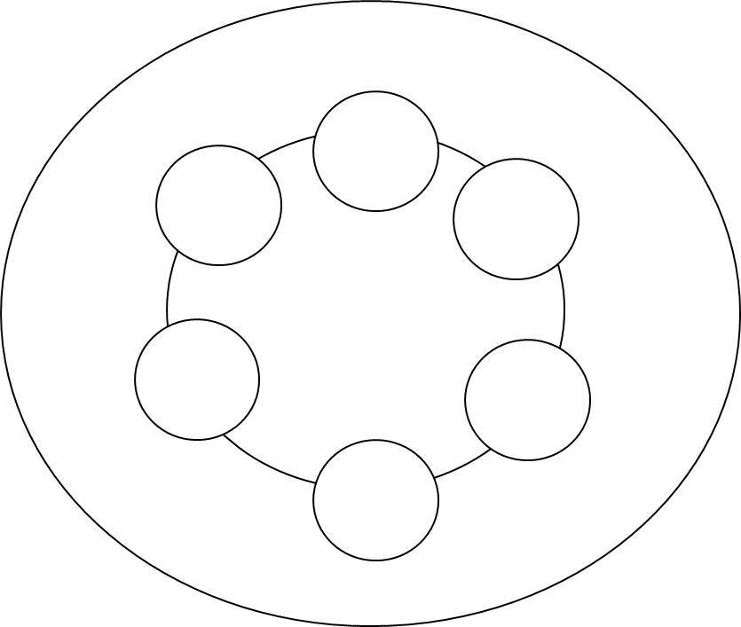

**5 WAYS TO PARTICPATE IN GOVERNMENT TO INFLUENCE DECISION MAKING**

So, let’s say that you are part of an association. You want to make your voice heard. You talk with your representatives about what you want. Here’s what you and your representatives can do to make the government listen and try to get what you want.

Associations, lobby groups and other “specific citizen groups” participate in all 5 ways to influence decisions making. Often, they use the 5 ways to draw attention to situations of injustice so governments know what is happening and that they need to do something!

.Trying to Influence Government & Being involved in the community = ACTIVE CITIZENSHIP