Students should know and understand the following terms:
Unit 3: Iroquois Confederacy Study Guide

Confederacy
Principles
Nations
Diversity
Society
Alliance
Matrilineal
Treaty
Allies
Hereditary
Negotiate
Consensus
Values
Collective Identity
Haudenosaunee

Students should be able to answer the following questions:
- How did the Iroquois Confederacy begin?

- a.) When was the Iroquois Confederacy? b.) Where would it be placed on a timeline?

- a.) Where was the Iroquois Confederacy? b.) What are the names of the 5 great lakes? c.) In what geographical order were the 5 original nations?

- a.) What were the names of the 5 original nations? b.) What roles did each of them play?

- a.) What was the name of the 6th nation to join the Confederacy? b.) What year did this take place?
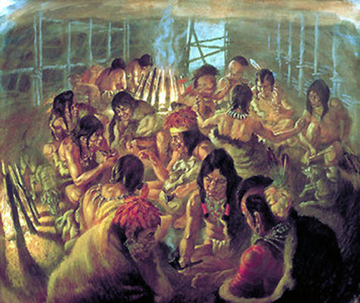
- a.) Who established the clans? b.) Why were they important? c.) How many clans existed? d.)How did clan members trace their history?
e.) What is a longhouse?
- a.) What roles & responsibilities did children have? b.) What roles & responsibilities did women have? c.) What roles & responsibilities did men have?

- a.) Who was a part of the grand council? b.) In what nation order were decisions made? c.) Why is consensus important?
- a.) What are Wampum Belts? b.) What are they made out of? c.) Why are they important?

10. a.) What is the Two Row Wampum Treaty? b.) What 3 values was it based on?

11. a.) What is the Hiawatha Wampum Belt? b.) What do the symbols represent? c.) What does the white line represent?

12. a.) What was the Great Law of Peace? b.) What do the branches represent? c.) What does the eagle represent? d.) What does the weapon represent? e.) What do the roots represent?
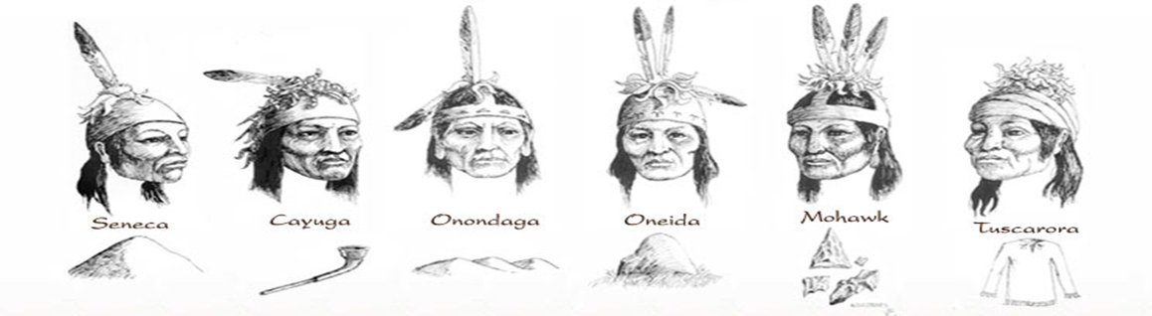

Your Unit 3 Test will be on Thursday, Feb. 15

